How to Display Your
Program Completion Certificate Badge
on Your LinkedIn Profile

A DIGITAL BADGE is a verified representation of specific learned skills that you can share on your social media profiles. Beyond higher education degree programs and training institutions, more and more it is specific industry-recognized skills and experience that are most valued. IntelliVen is pleased to offer digital badges certifying the highly desired skills taught in our programs.

Upon evaluation of your team’s final submission and assessment of your individual participation throughout the program, a certificate of completion will be awarded and sent to you via email. The graphic in the transmittal email message is hot linked to the actual certificate. Follow the instructions below to add your badge as a Certificate in the Accomplishments section of your LinkedIn profile:

- Sign-in to LinkedIn and go to your profile page.
- If your profile is not already set up to display Accomplishments click the
Add profile section button (see below) and expand the Background menu.

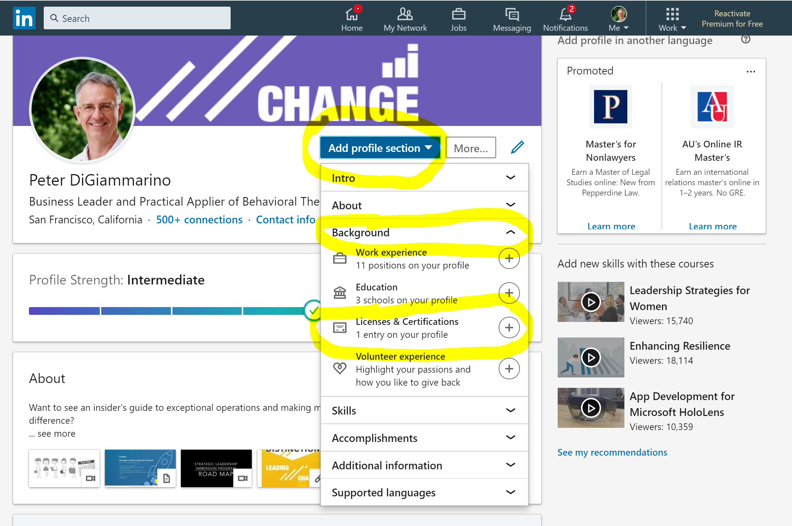

- Select Licenses & Certifications to open the following dialog box:
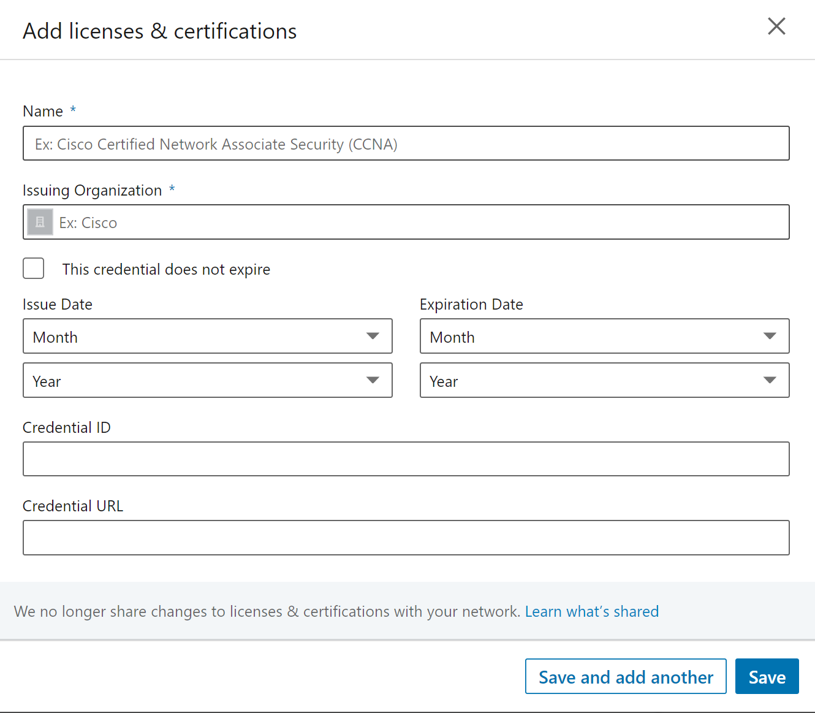

- Click the badge icon in the email message notifying you of the certificate award to open a new window that displays the public assertion and badge verification page:
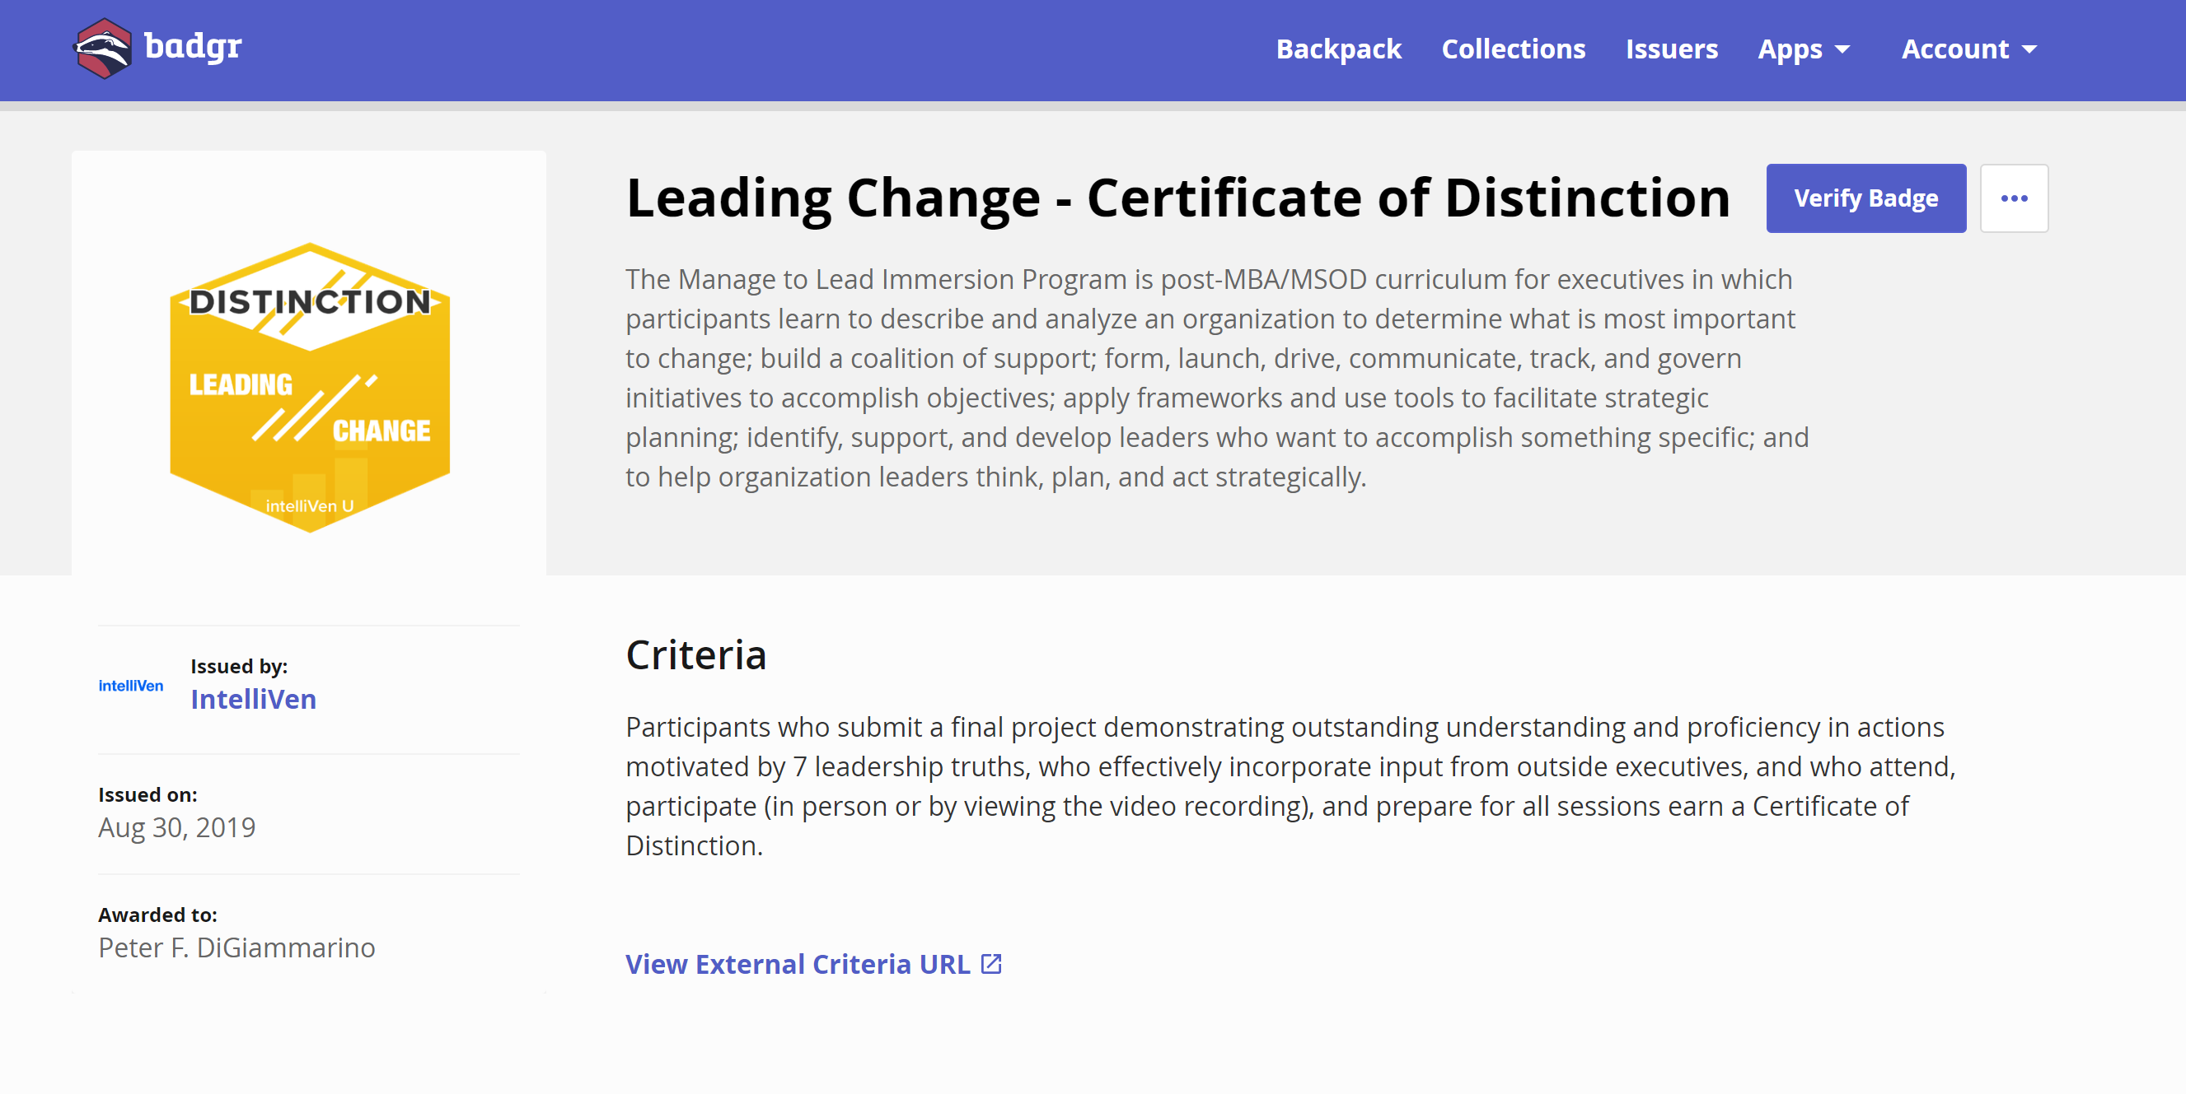
- Copy and paste the information on this page to the
LinkedIn License & Certification dialog box:

- Name: Enter the badge name as shown on the badge verification page.
- Issuing Organization: IntelliVen is the badge issuer. Upon entry you should see the IntelliVen LinkedIn page logo appear, click it to select IntelliVen as the issuer.
- Check the box for: This certificate does not expire.

- Issue Date: Enter the date that appears on the badge verification page.

- Credential ID: Leave blank
- Certification URL: Paste the URL of the public assertion and badge verification page.
- Click Save.

- From your LinkedIn profile, navigate to the Licenses & Certifications section to view your badge:
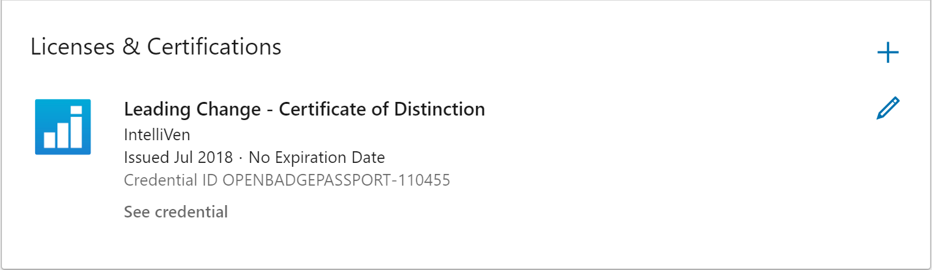

- Use the buttons under the graphic in the transmittal email message to share your certificate of completion via social media.

If you have any trouble or questions following these instructions get in touch with instructors or your Principal Consultant for assistance.

